|  |  |  |
| --- | --- | --- |
|  | به نام خدا |  |
| **دانشگاه تهران**  **دانشکده‌ مهندسی برق و کامپیوتر**  **کنترل صنعتی**  **تمرین 4** | | |

|  |  |
| --- | --- |
| محمد مشرقی | نام و نام خانوادگی |
| 810199492 | شماره‌ دانشجویی |
|  | تاریخ ارسال گزارش |

­

فهرست

1- 3

A 3

B 4

C 5

2 8

A 8

B 8

C 9

3 12

4 13

A 13

B 14

C 15

D 16

E 17

F 18

Q5 19

CC & CHR & ZN_open_loop: 21

Damped ocsillation 23

ZN_closed_loop 23

process response 24

Ciancone Marline 25

Fertik 26

# 1-

## A

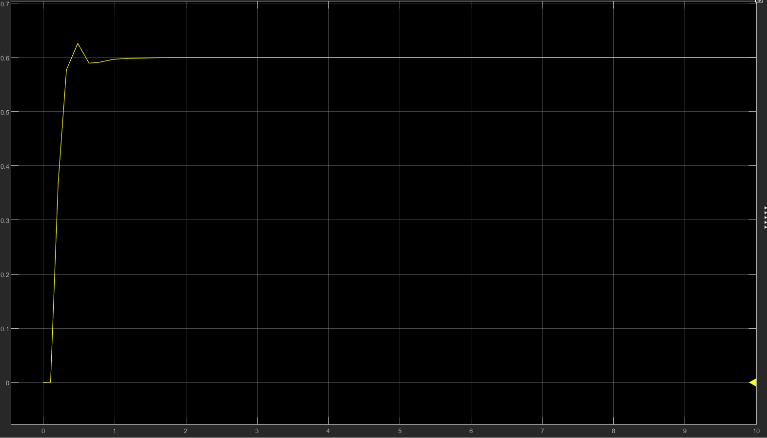

For findin $K_{u} and T_{u}$ we try to increase the gain until it swining

The $K_{u}=4.28 and T_{u}=2.41-2.05=0.36 which w_{u}=2\frac{π}{0.36}=17.4532$

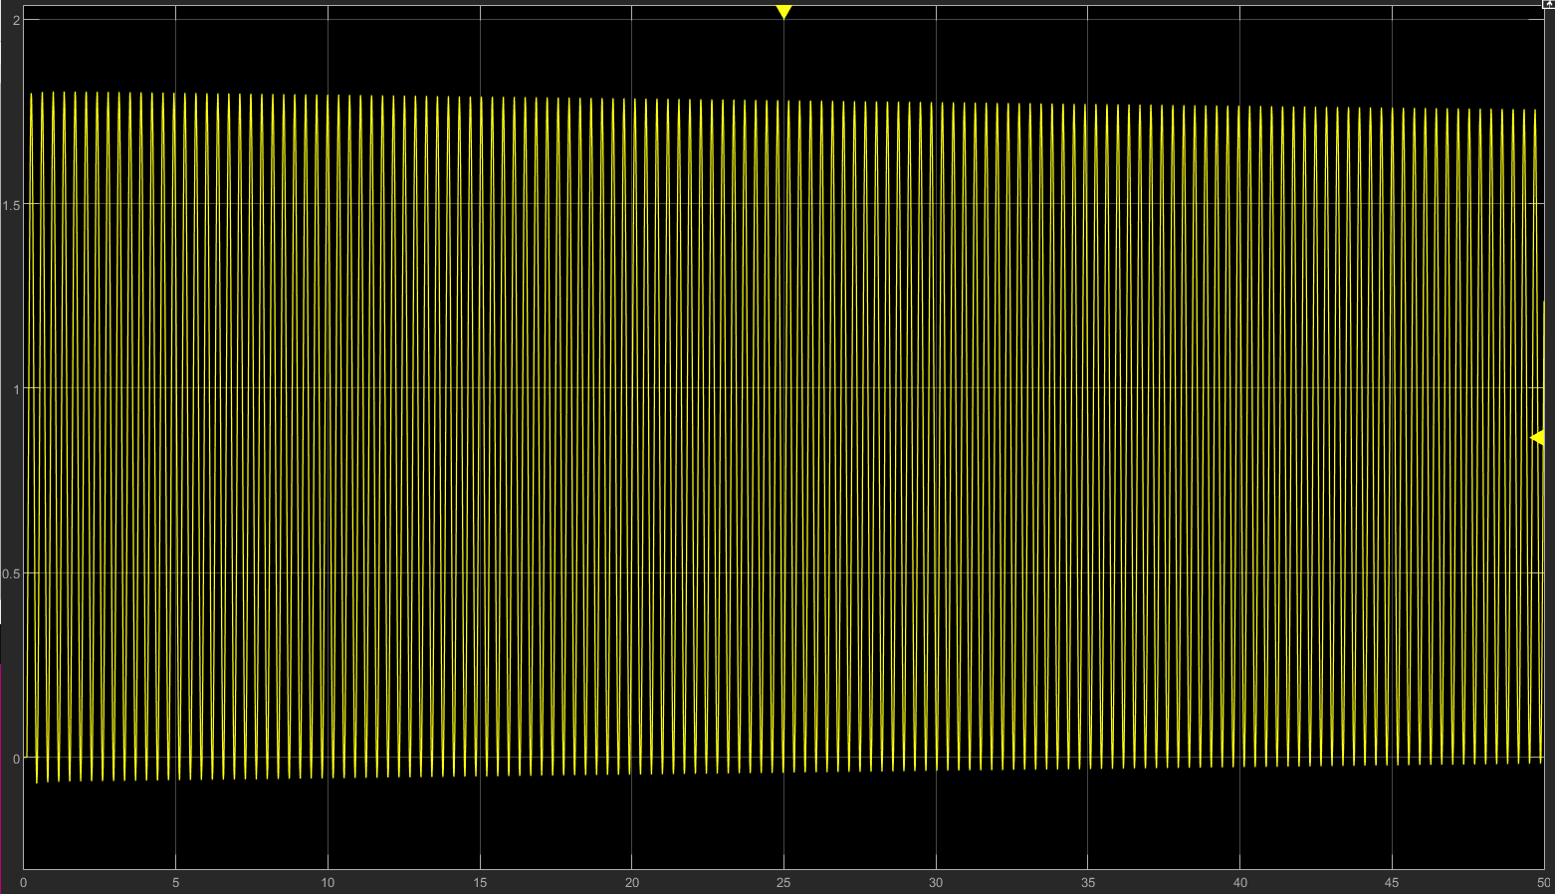

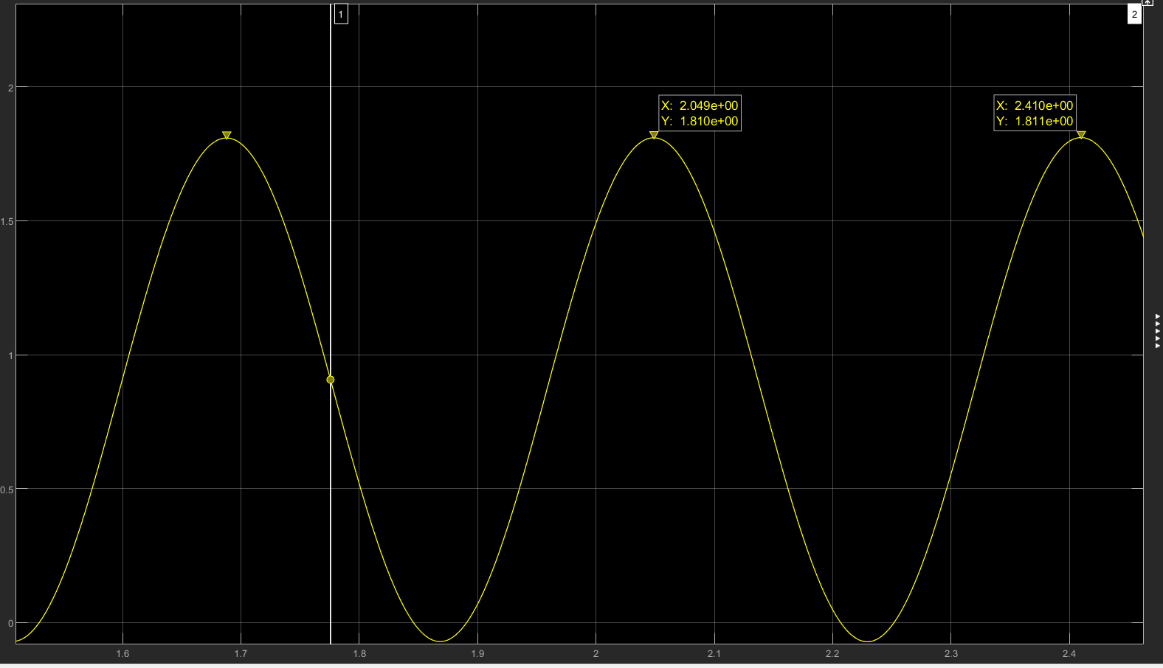

## B

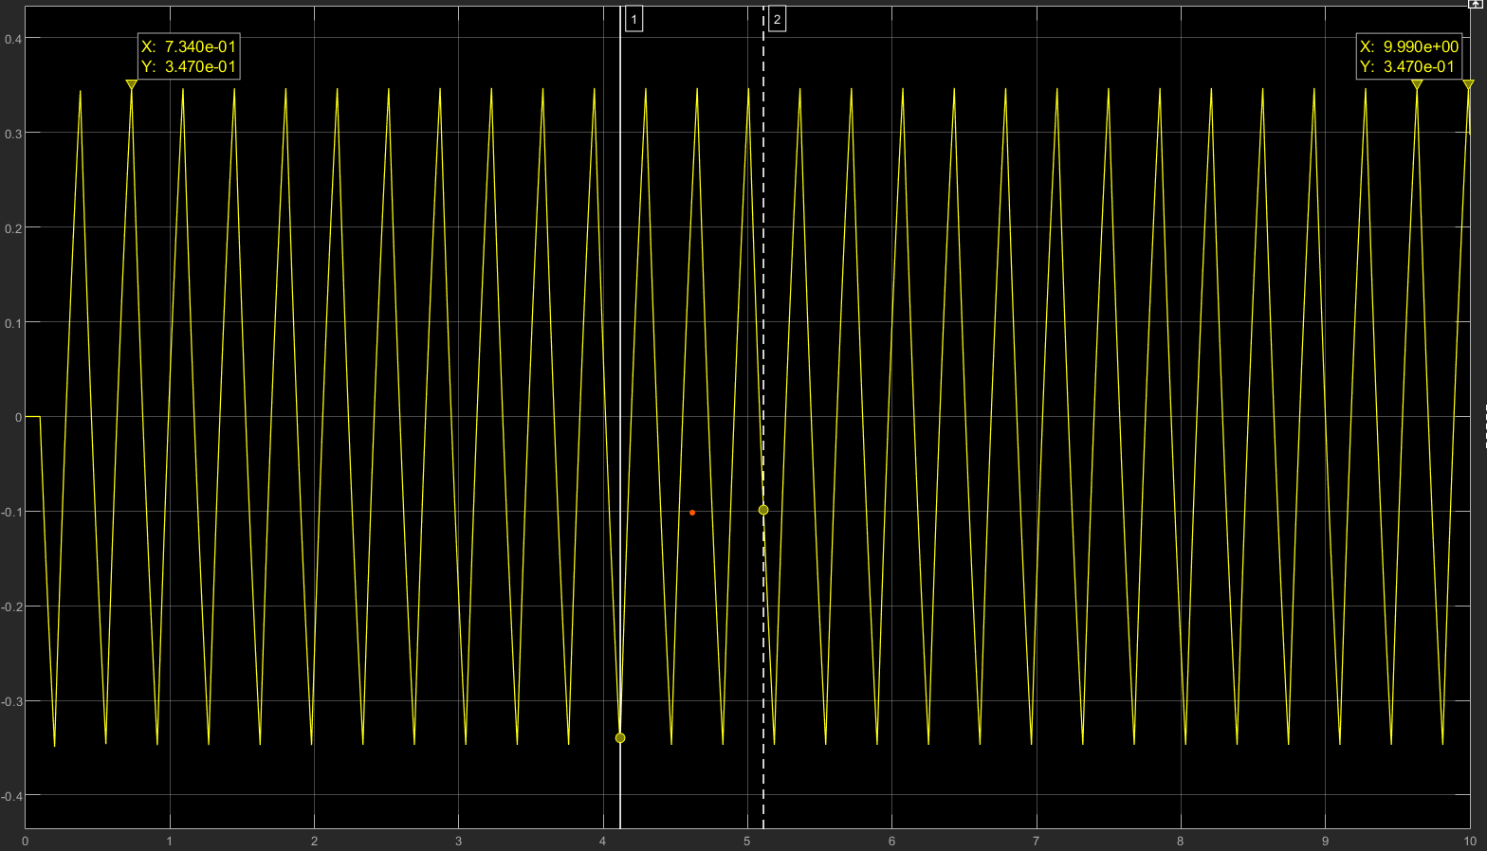

$$K_{u}=\frac{4d}{πa}=\frac{40}{π3.47}=3.67$$

$$T_{u}=0.361 w_{u}=17.4$$

## C

Output signal with noise without relay:

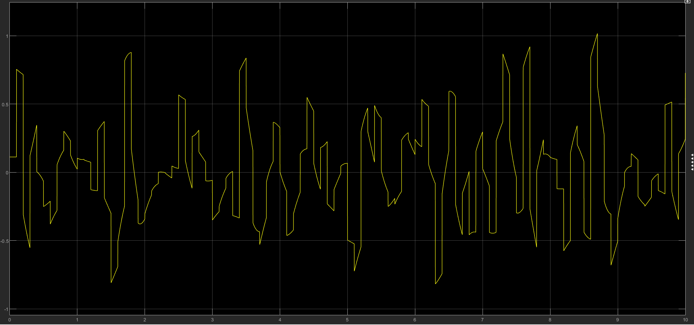

The control signal :

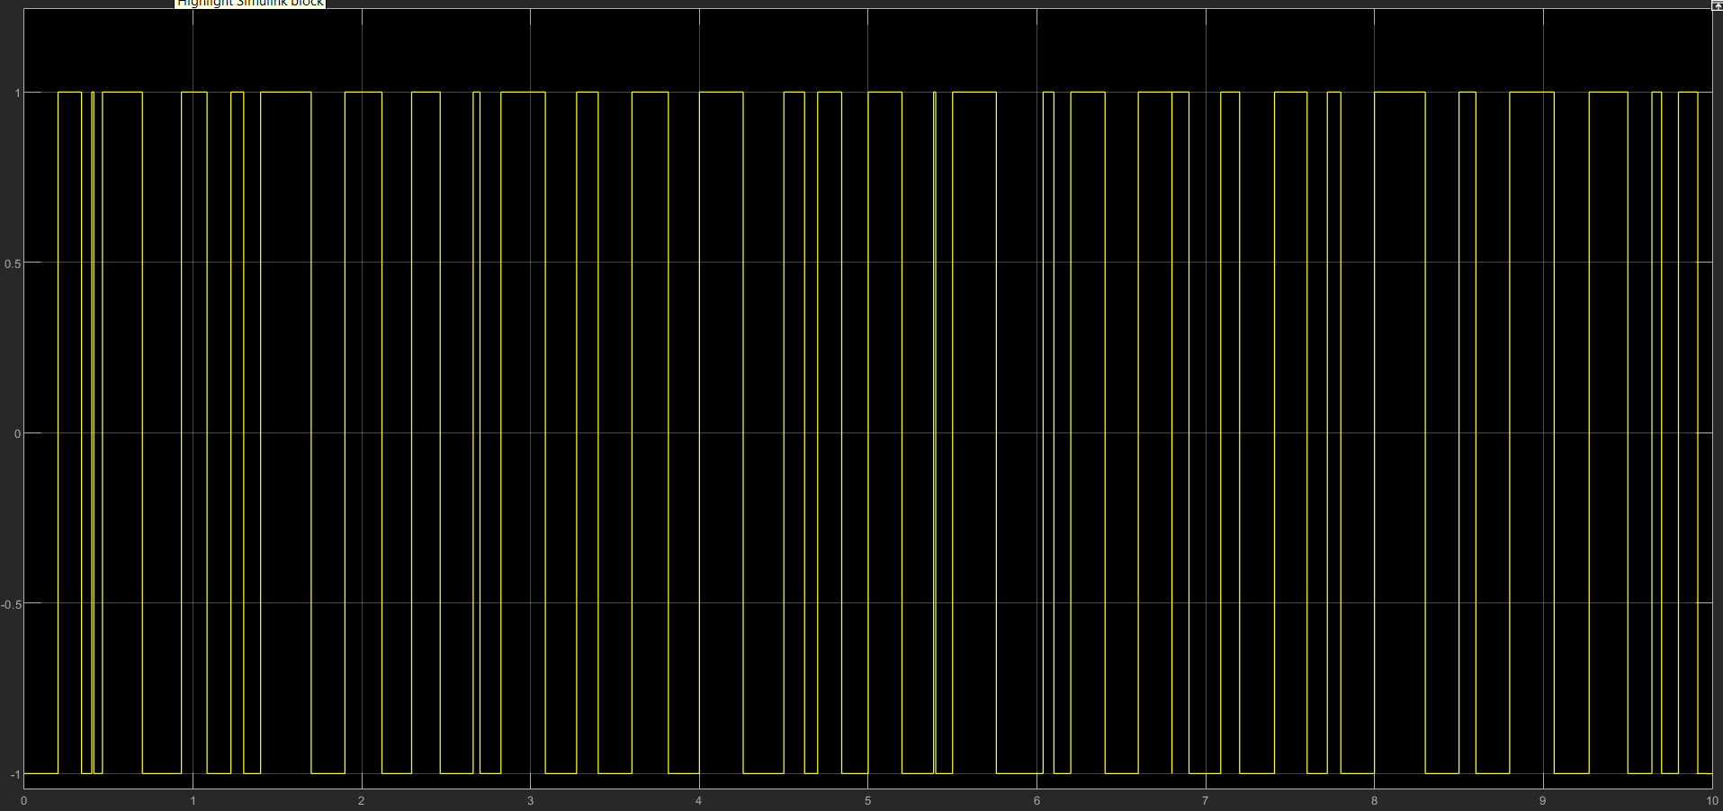

After changing relay:

The output:

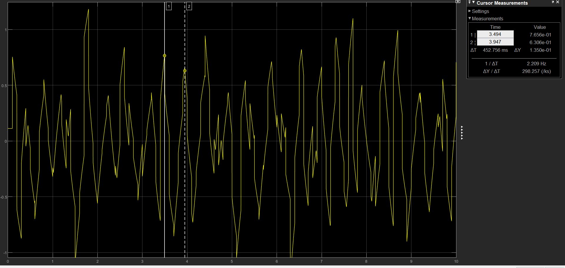

$$T=0.452 f=2.2 w_{u}=13.8 K_{u}=\frac{4d}{π{\left(a^{2}-∈^{2}\right)}^{0.5}}=\frac{4}{π({0.76}^{2}-{0.5}^{2})}=3.886$$

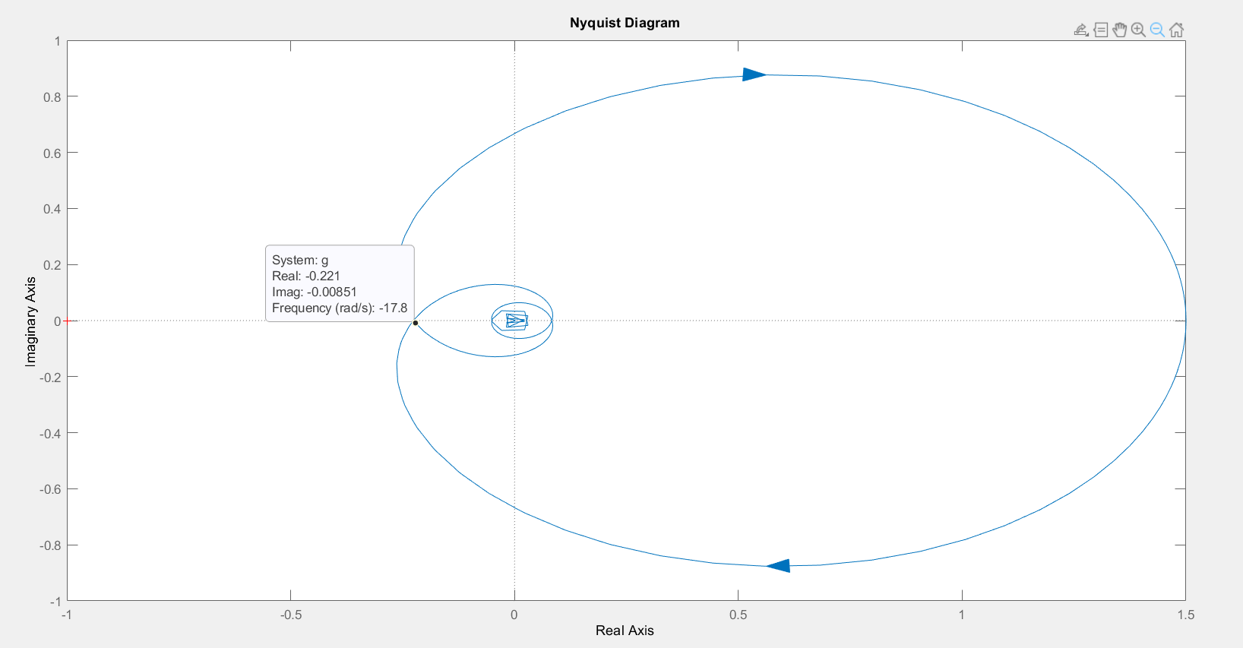D

As can be seen, $w=17.8 , K_{u}=\frac{1}{0.221}=4.5$

# 2

## A

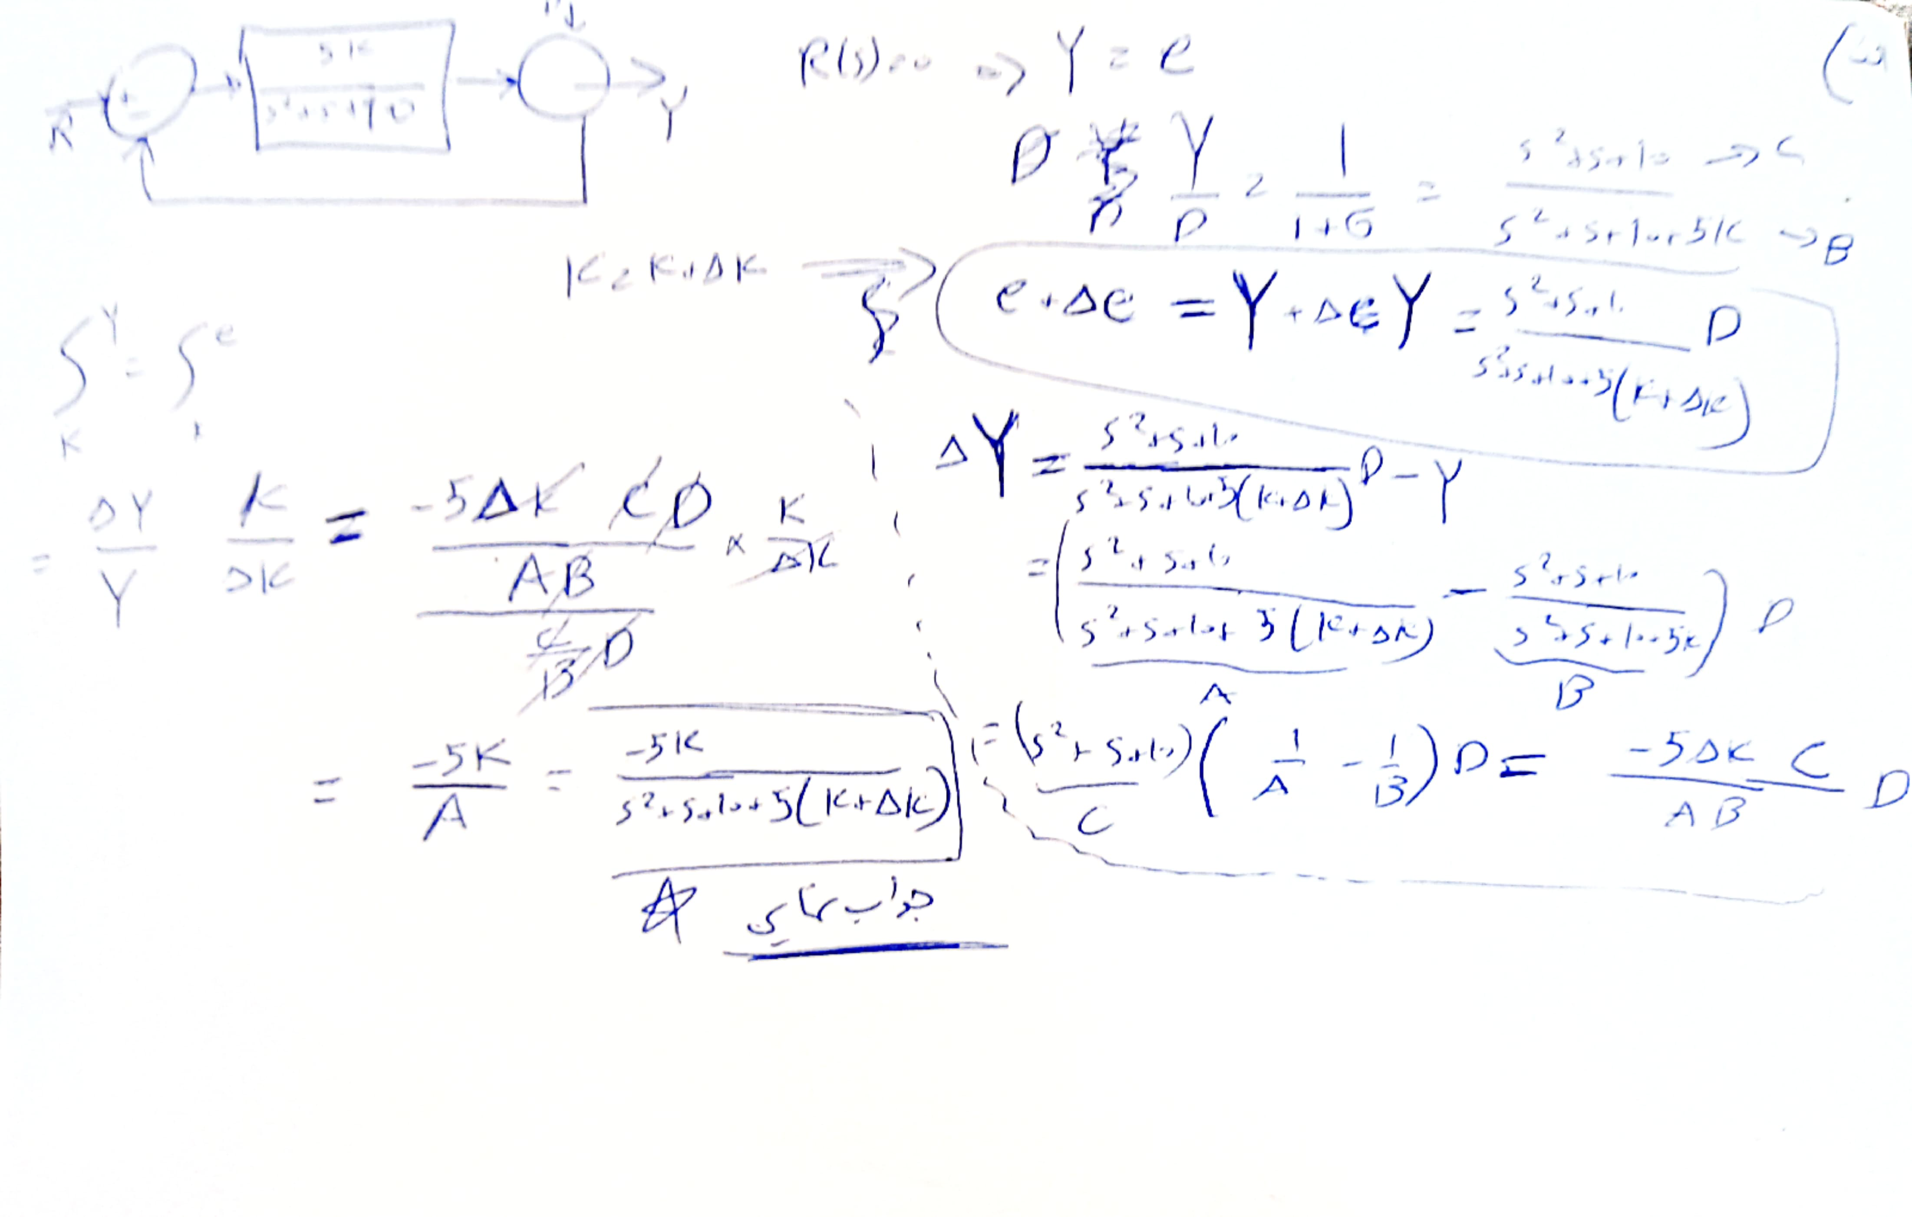

## B

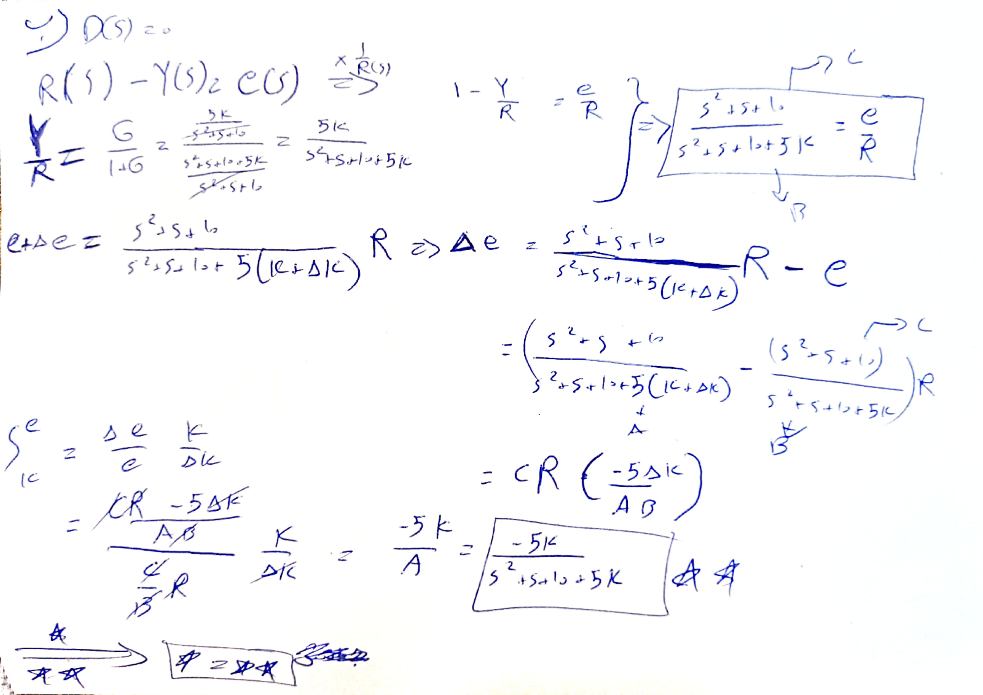

## C

From seeing two previous part we find out that the sensitivity of k for both input and disturbance are the same and have the same effect on output.

For simulation we consider $∆K=0.1$ and for disturbance we consider when it as -1 because when in it pass from feedback the value become 1.

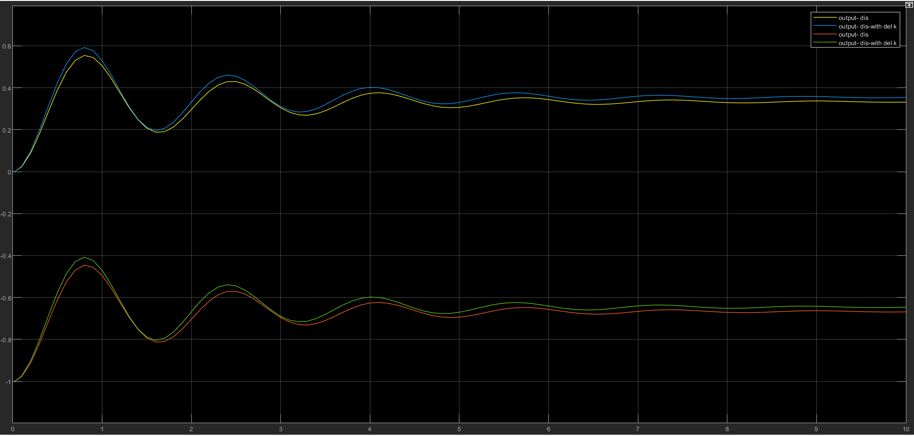The outputs:

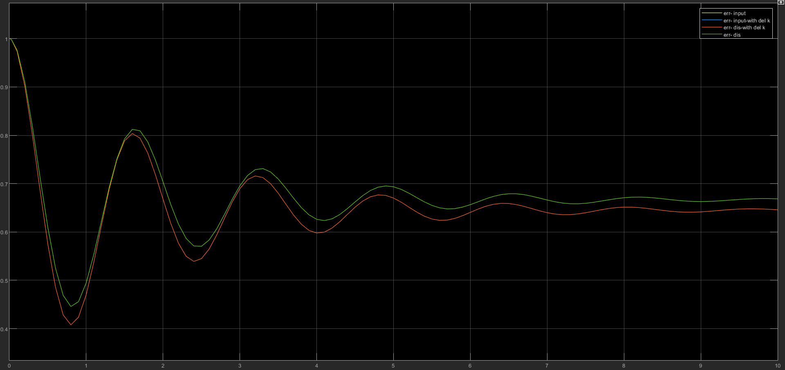the error as can be seen in here both input and dis are the same and both input and dis with delta k are the same too.

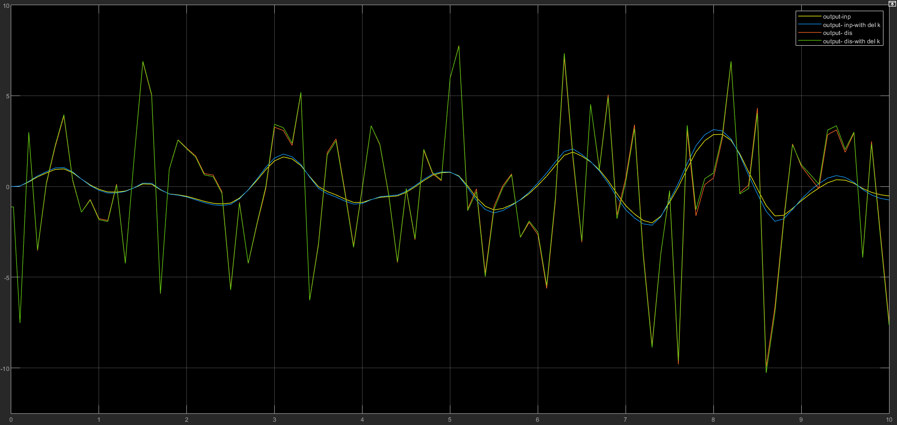output with white band noice:

As before the sesivity is the same like before.

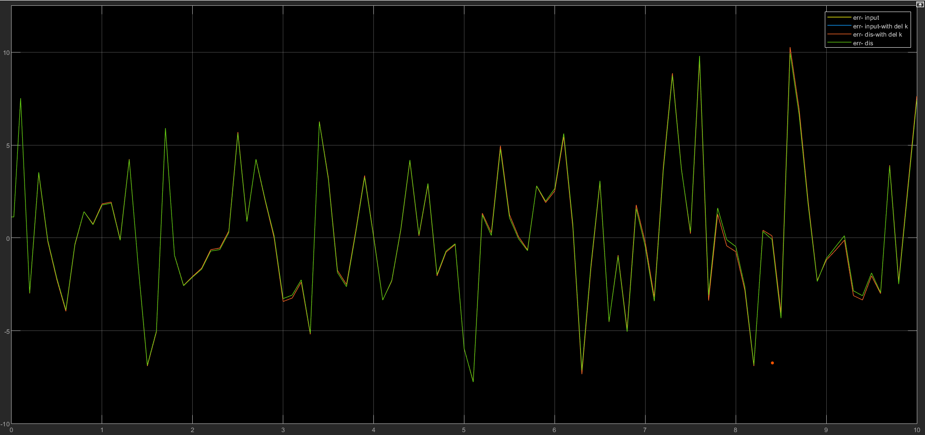

And finally as can be seen for $S_{k}^{y} when R=\left(0\right)and {S'}_{k}^{y} when D=\left(0\right)$

$$S_{k}^{y}-{S^{'}}_{k}^{y}=0$$

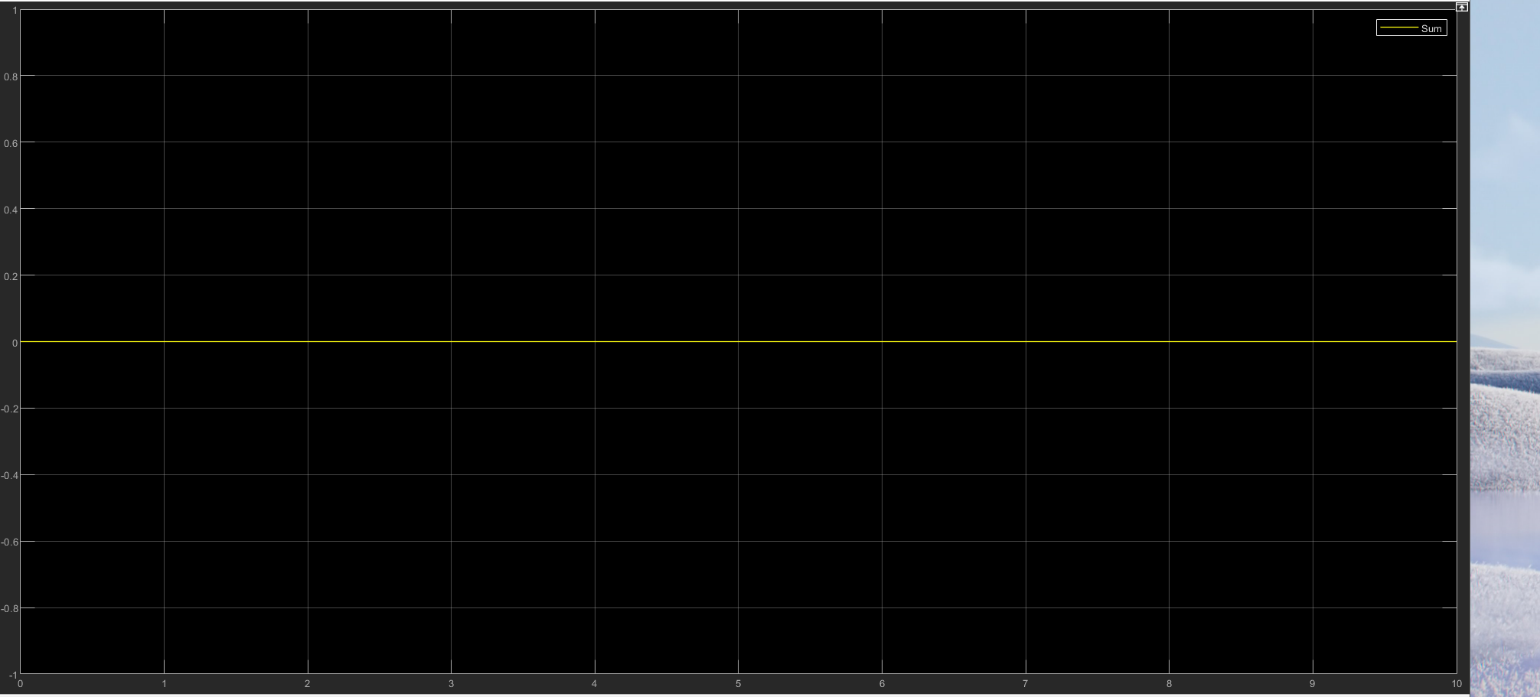

# 3



# 4

## A

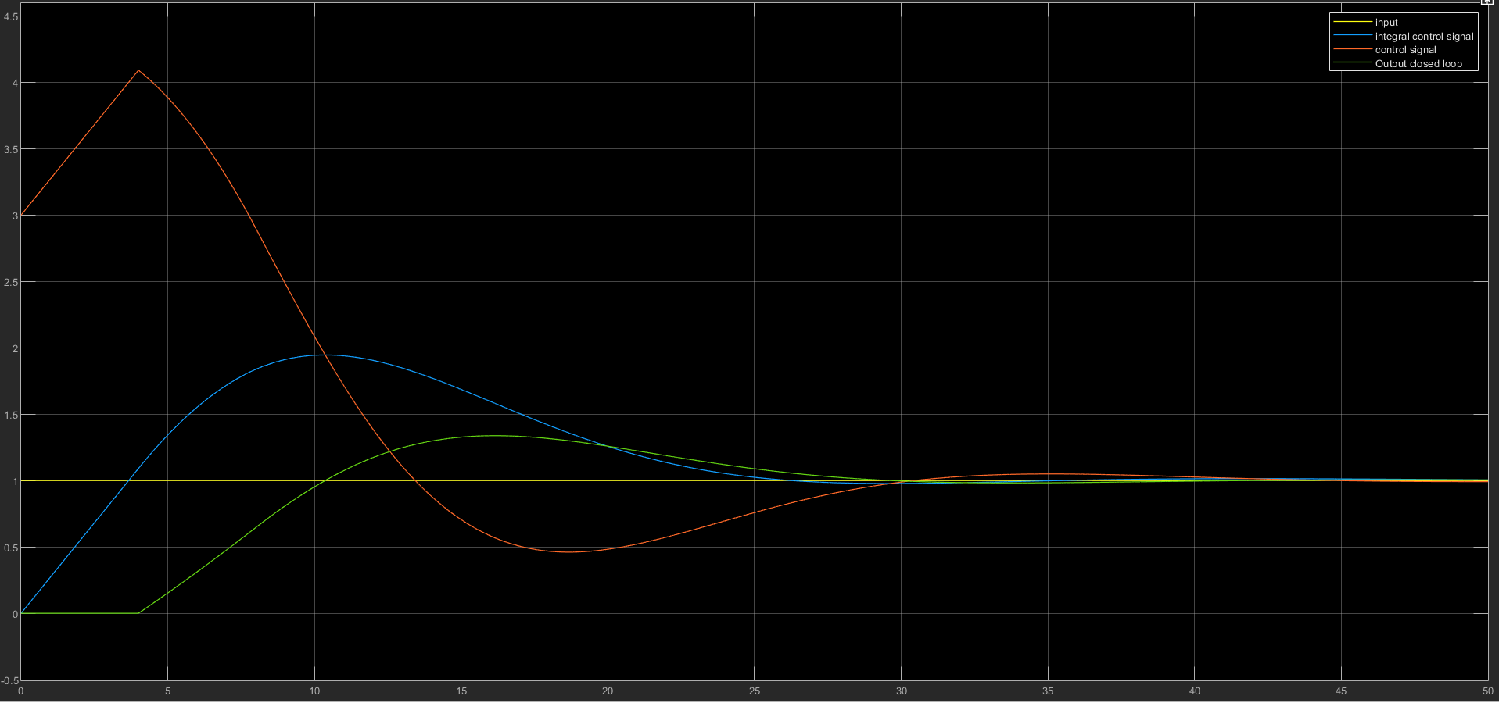As wanted we have 3 + 1 signal :

As you can see from the start, our signal controller starts from 3 because k sub p equals three, and the integral controller becomes more; after 4 seconds, the output starts to rise, so the error decreases, and the control signal decreases.

When the error becomes zero and the output is more than the input, the integral starts to decrease.

## B

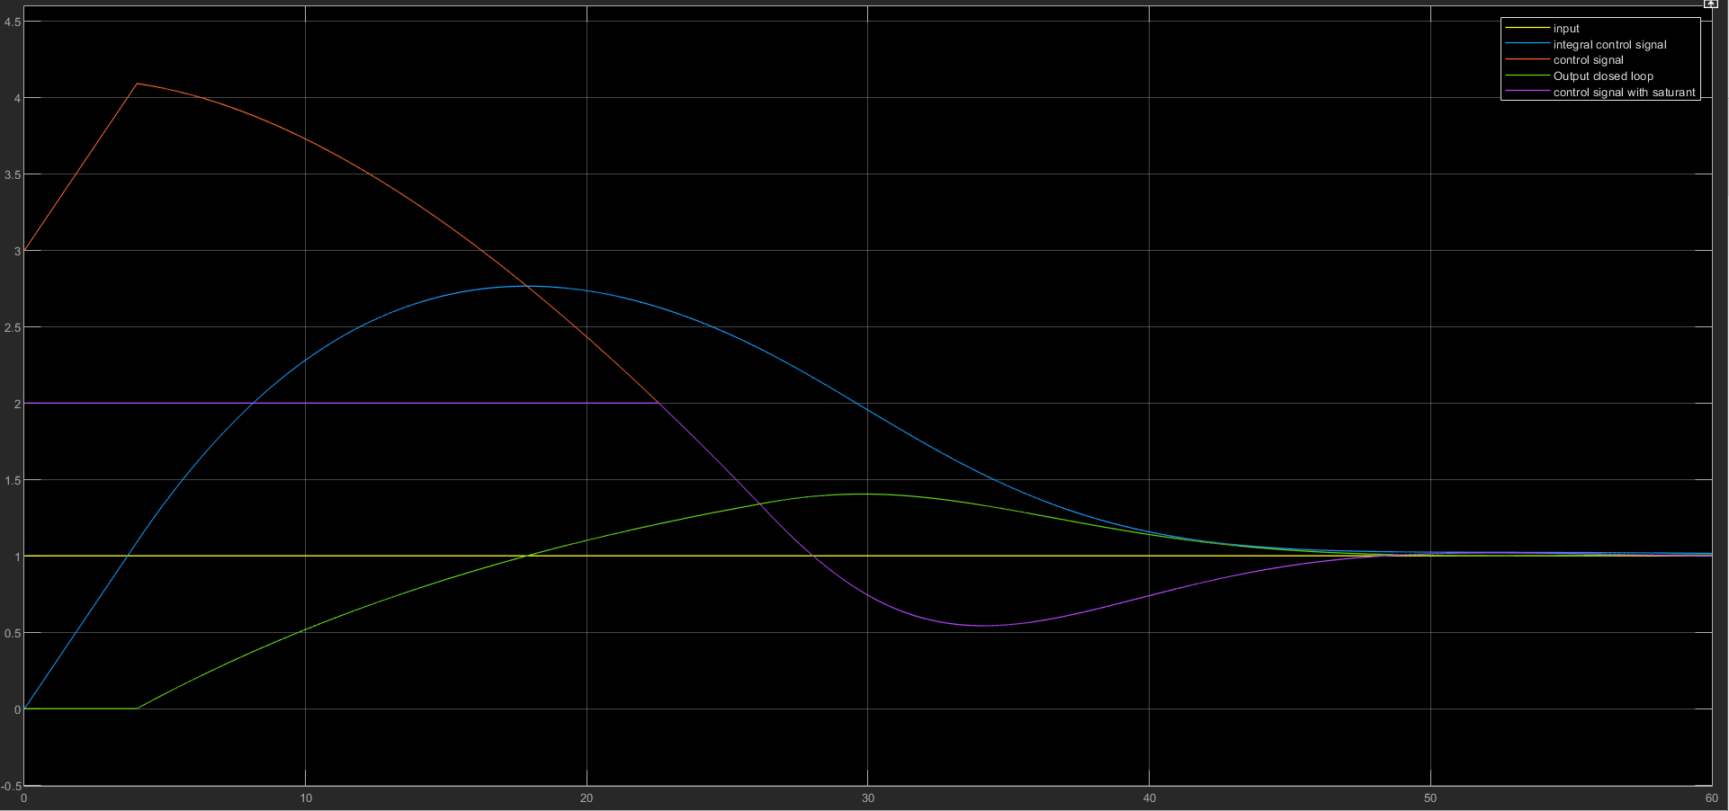

As we can see in this part and the previous part, In here cause of saturation, It takes more than 18 seconds to reach the input. (and in previous, the max of the integral control signal was about two, but here it is 2.75 (because of the error))

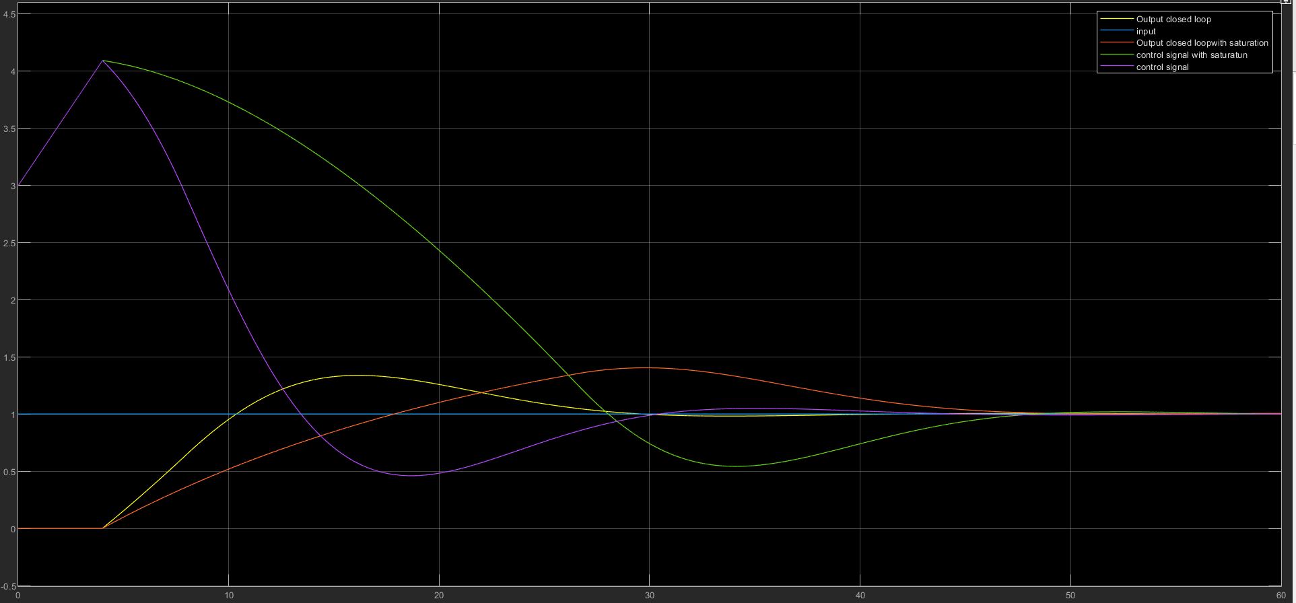

When it comes to comparison, we can easily see it takes more time for both the output signal and control signal to reach the input.

## C

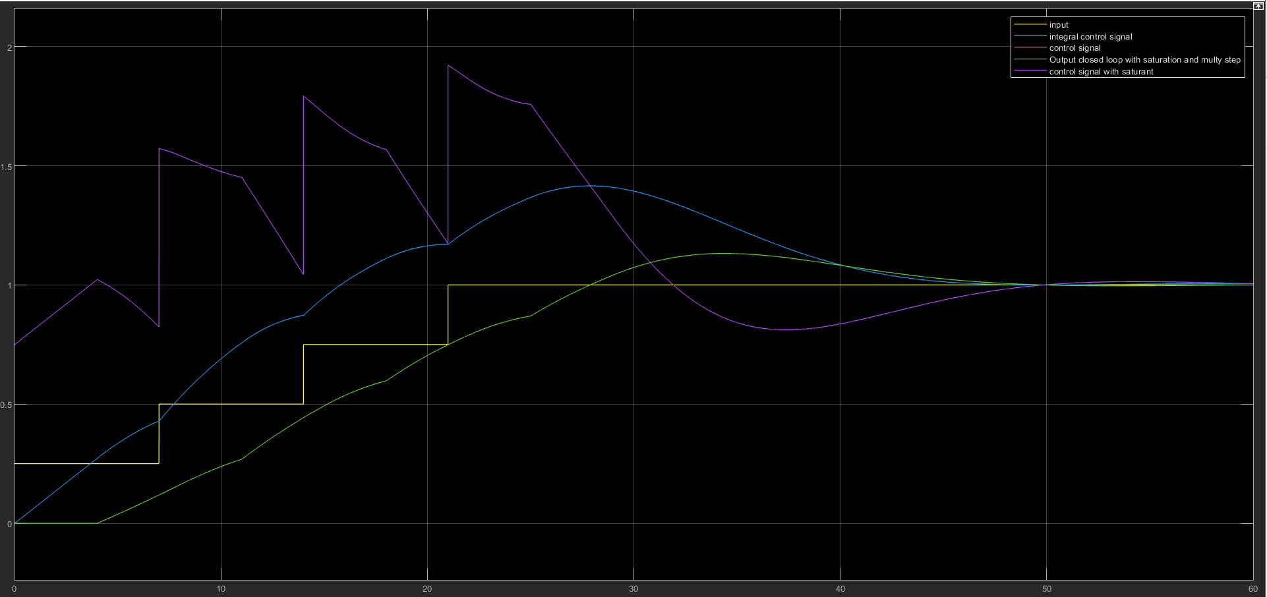

As shown in the picture, we divided it into four pieces, each one starting 7 seconds after the other.

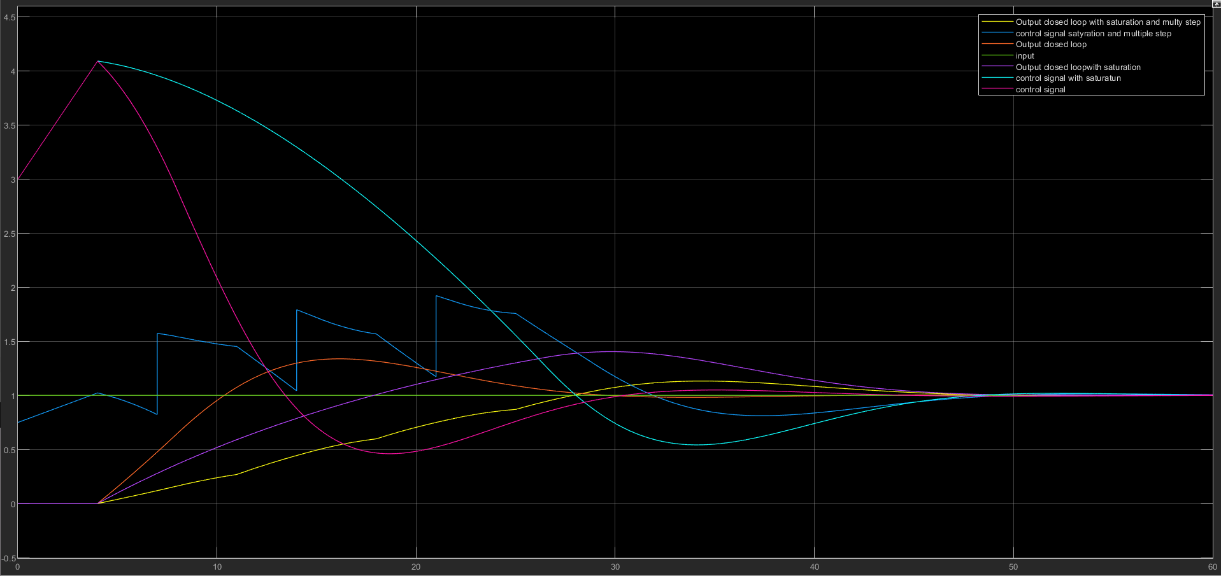

As we compare from the last part, it takes longer to reach the steady state. However, the positive point of this part is that the signal control didn’t go to the saturation area.

## D

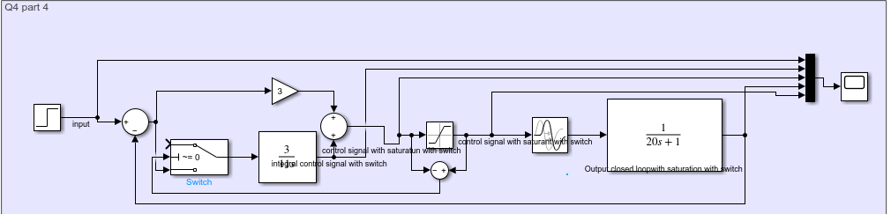

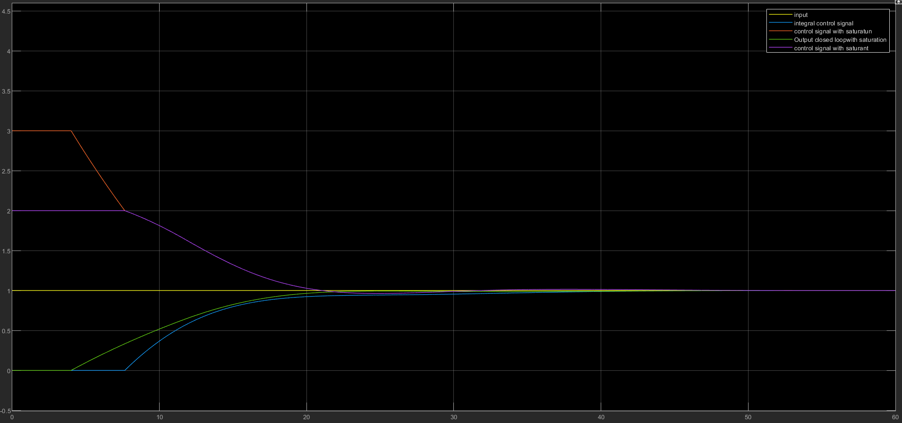

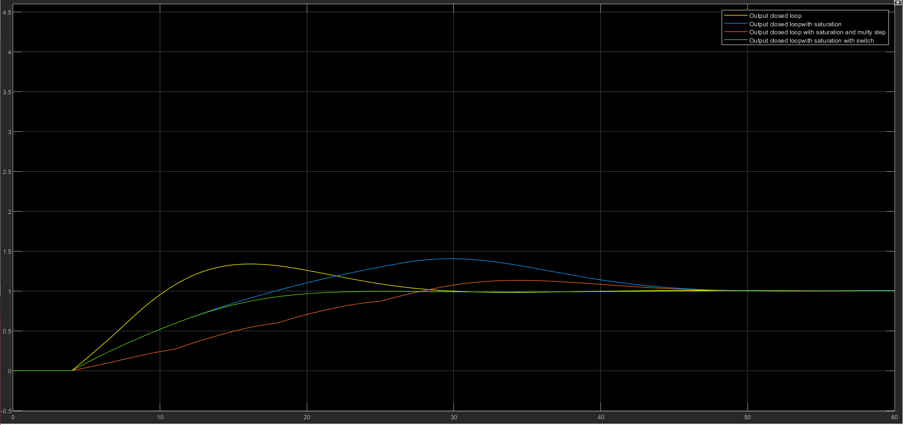As the picture shows, it takes less time to reach a steady state, and we don’t Integral until the control signal doesn’t be in saturation area(wined up).

The system reach steady space sonner than other system but the problem in here is that the system is unlinear.

## E

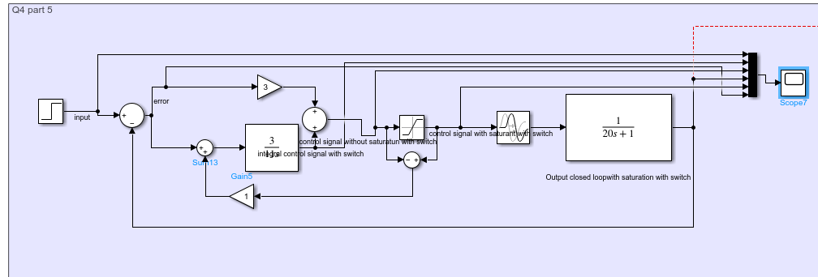

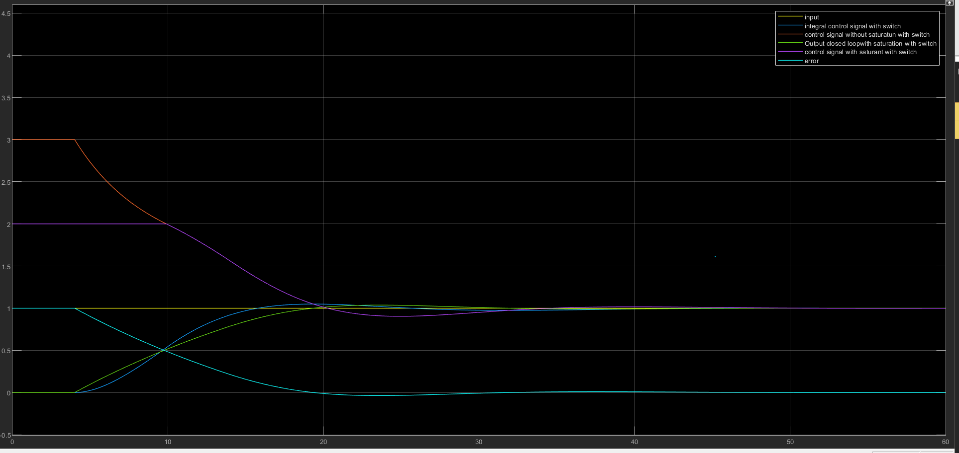

Now our system is linear and we can azalyze it.

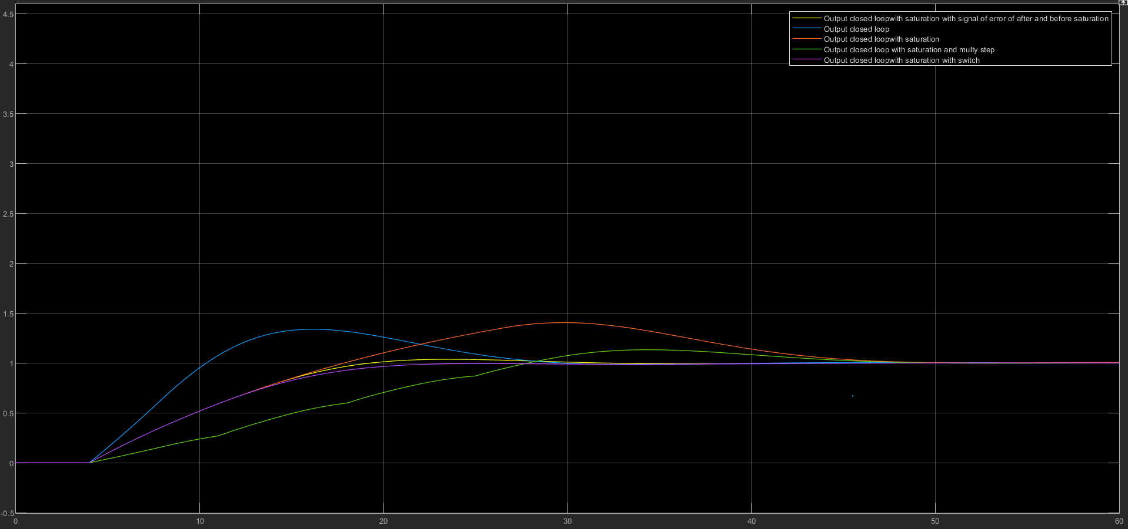

The system works as the same with previous system(a little better).

## F

With decreasing $T_{e2}$ the gain will be more so the gain of $integral block$ become zero faster than befor ane move smoother. But when $T_{e2}$ increase the gain will be decrease so the the gain of $integral block$ takes more time become zero.

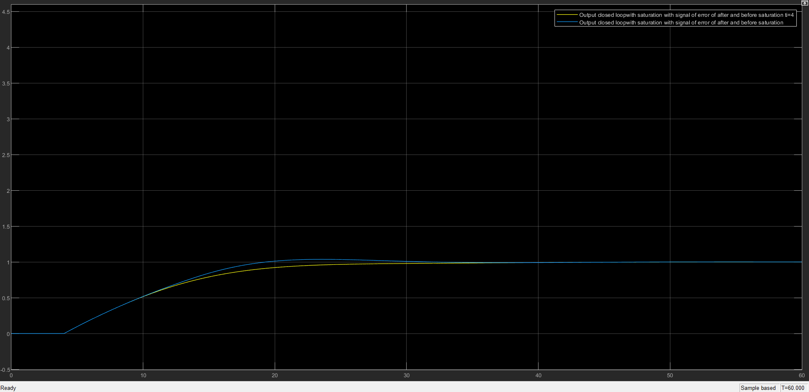

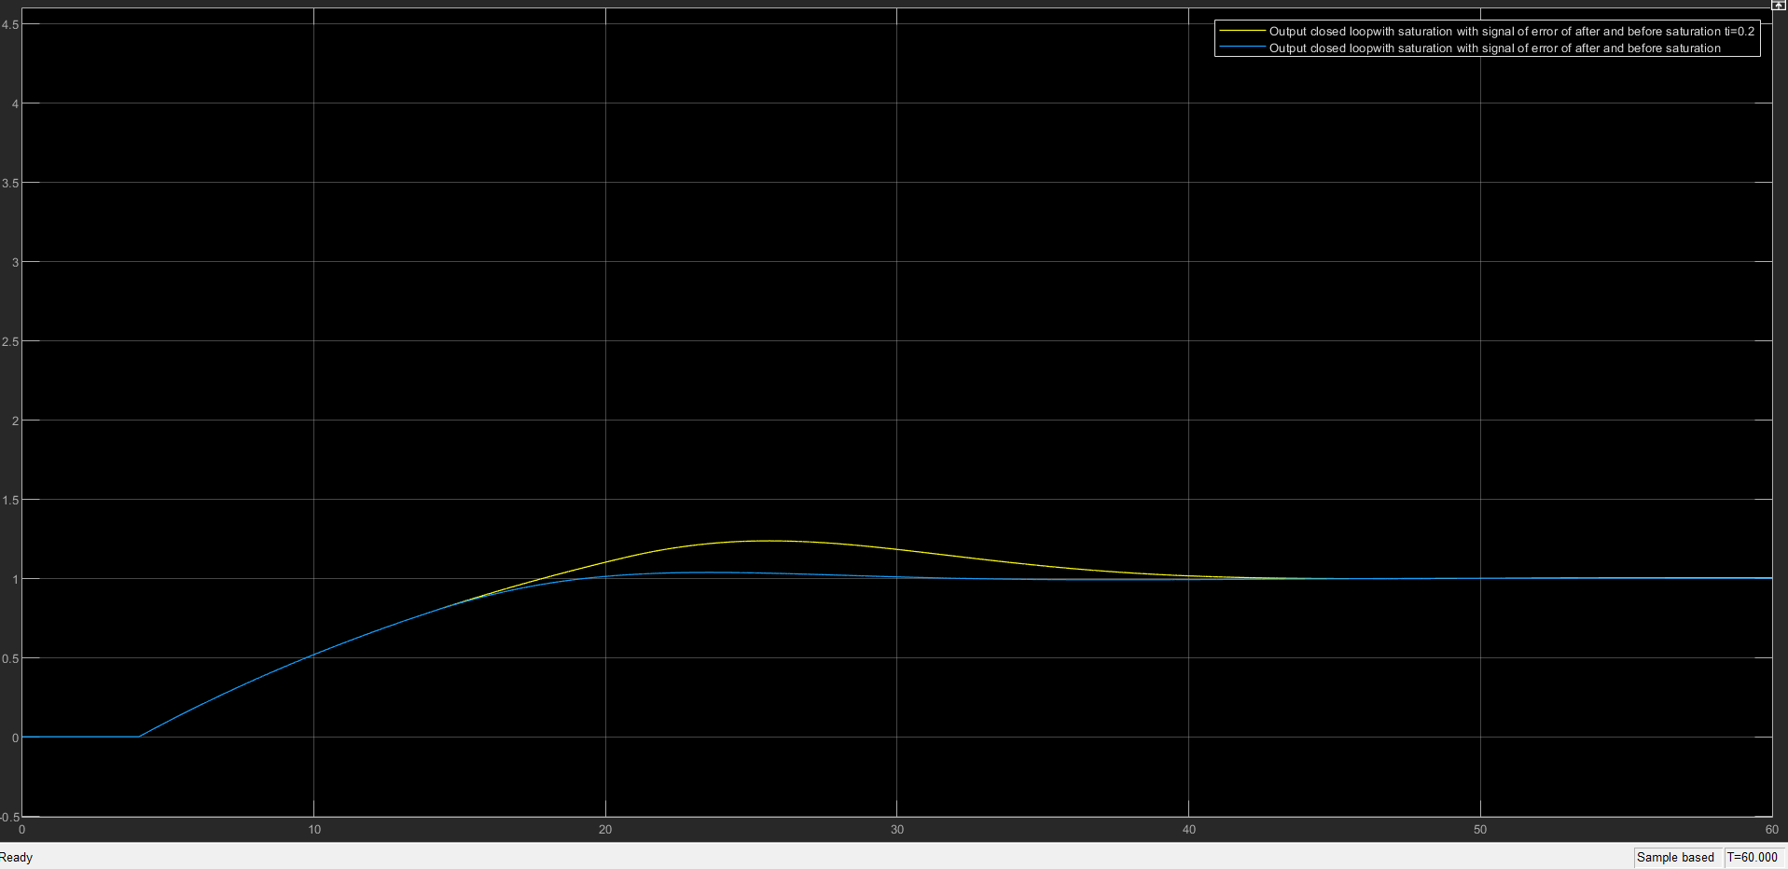

# Q5

we must caculate a first order model:

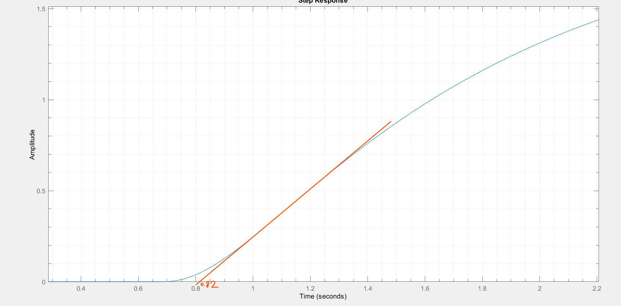

$$τ_{d}=0.82$$

And then we use two point method to find $τ$:

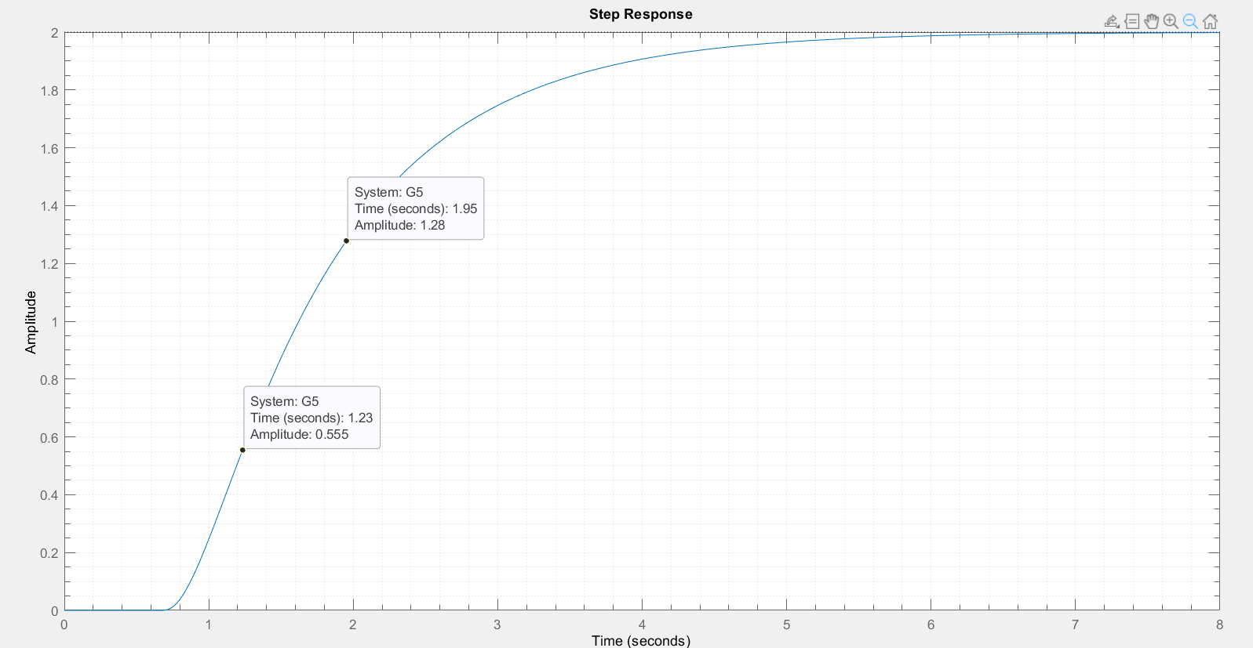

And for $τ=1.5\left(1.95-1.23\right)=+1.08 And K=2$ so $α=0.76$

$G=\frac{2e^{-0.82s}}{1.08 s+1}$

­

Max slope:

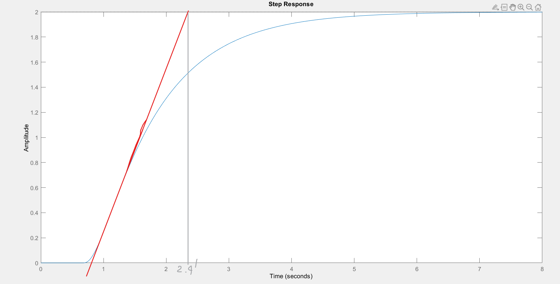

So the parameters for PID stands for :

$G=\frac{2e^{-0.82s}}{(2.4-0.82) s+1}$

­

One point

$$G=\frac{2e^{-0.82s}}{(1.95-0.82) s+1}$$

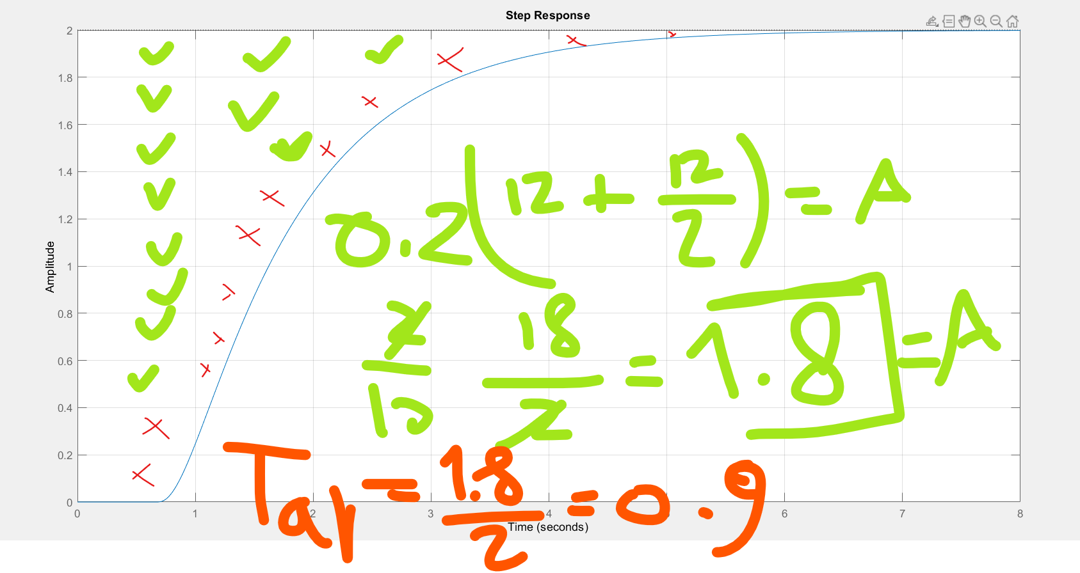ATR

$$G=\frac{2e^{-0.82s}}{(0.9) s+1}$$

Now we caculate the error:

err_max_slope = 0.0012

err_one_point = 4.4576e-05

err_two_point = 4.3508e-05

err_ART = 4.7052e-04

Acording to the error the best model is two point model:

Which is:

$G=\frac{2e^{-0.82s}}{1.08 s+1}$

­

## CC & CHR & ZN_open_loop:

For CC, we must use two point estimation model which is best one from the error

ZN_open_loop



CHR



CC

Result at the end!

## Damped ocsillation



Which $K_{dmp} is equal to K_{gain}when\frac{e_{1}}{e_{2}} equals 4$

## ZN_closed_loop

$$K_{u}and t_{u} can find from increasing k until system swinging$$

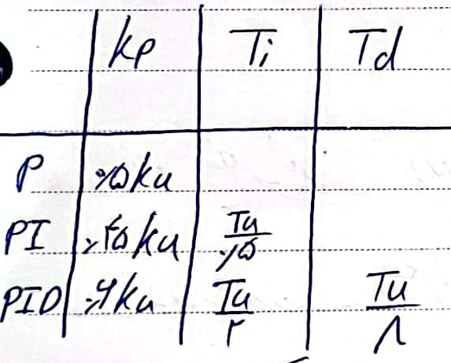

## process response



## Ciancone Marline

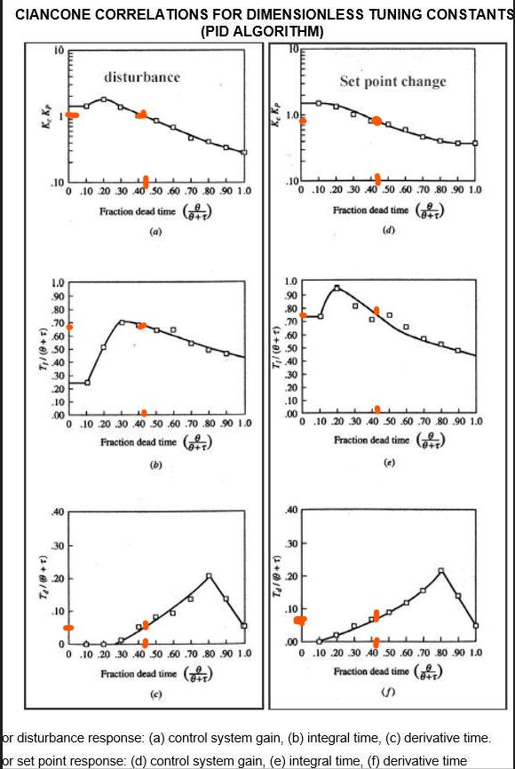

## Fertik

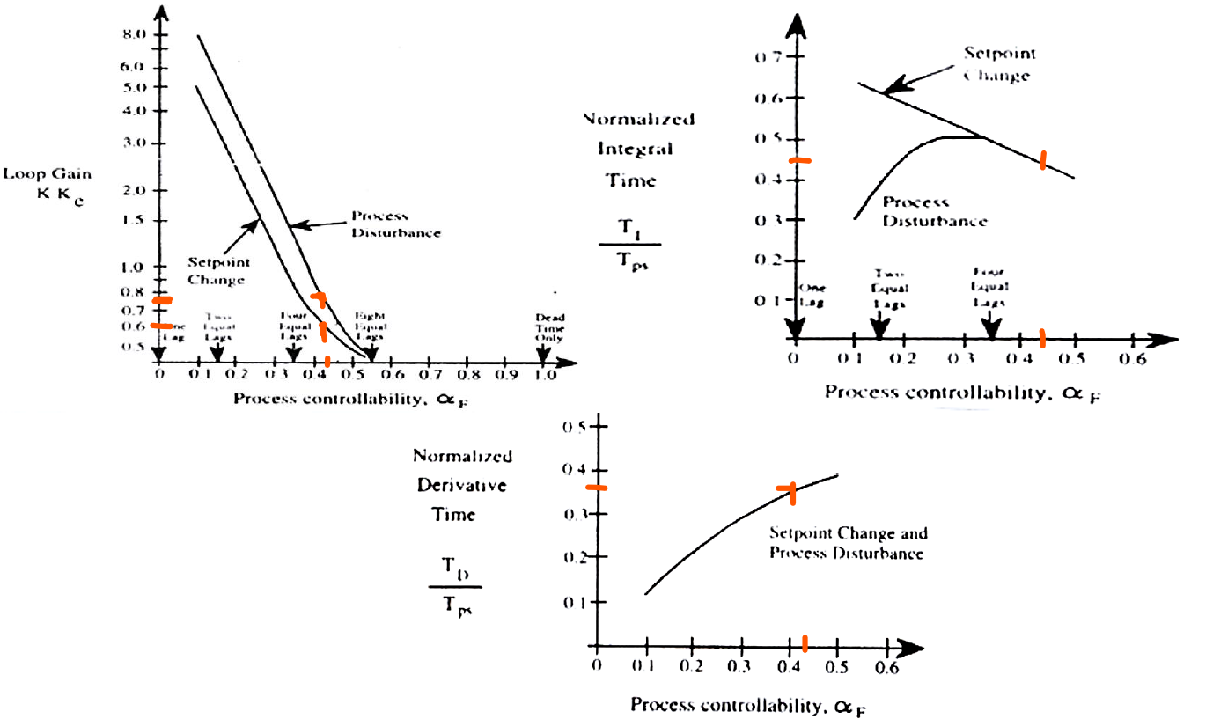

Which $α_{f}=\frac{τ_{d}}{τ+τ_{d}}$

|  |  |  |  |
| --- | --- | --- | --- |
| method_name | kp | Ti | Td |
| ZN_open_loop | 0.790 | 1.640 | 0.410 |
| method_cc | 1.003 | 1.572 | 0.262 |
| CHR ref track 0%OS | 0.395 | 1.080 | 0.410 |
| CHR ref track 20%OS | 0.626 | 1.512 | 0.385 |
| CHR rem dis 0%OS | 0.626 | 2.592 | 0.344 |
| CHR rem dis 20%OS | 0.790 | 2.160 | 0.344 |
| Damped Ocsillation | 0.858 | 0.850 | 0.340 |
| ZN_close_loop | 0.826 | 1.375 | 0.344 |
| Fertik ref track | 0.300 | 0.855 | 0.684 |
| Fertik rem dis | 0.365 | 0.855 | 0.684 |
| Ciancone-Marline ref track | 0.400 | 1.387 | 1.140 |
| Ciancone-Marline rem dis | 0.475 | 1.292 | 0.760 |
| process response | 0.688 | 2.145 | 0.285 |

From the table we can find out process response has the max amount of Ti and Damped Ocsillation has min value for it.

From the table we can find out method_cc has the max amount of kp and Fertik ref track

has min value for it.

From the table we can find out Ciancone-Marline ref track has the max amount of Td and Fertik ref track has men value for it.

|  |  |  |  |  |  |
| --- | --- | --- | --- | --- | --- |
| method_name | RiseTime | SettlingTime | Overshoot | Peak | PeakTime |
| ZN_open_loop | 0.666 | 6.112 | 13.810 | 1.138 | 2.017 |
| method_cc | 0.525 | 7.343 | 47.259 | 1.473 | 1.991 |
| CHR ref track 0%OS | 1.445 | 6.823 | 9.188 | 1.092 | 4.210 |
| CHR ref track 20%OS | 0.876 | 5.180 | 4.102 | 1.041 | 4.101 |
| CHR rem dis 0%OS | 3.304 | 10.045 | 0.000 | 1.000 | 30.000 |
| CHR rem dis 20%OS | 0.709 | 5.732 | 7.897 | 1.079 | 2.011 |
| Damped Ocsillation | 0.527 | 5.495 | 66.669 | 1.667 | 2.156 |
| ZN_close_loop | 0.610 | 4.945 | 29.453 | 1.295 | 2.077 |
| Fertik ref track | 1.814 | 7.878 | 14.003 | 1.140 | 4.850 |
| Fertik rem dis | 1.457 | 9.891 | 18.258 | 1.183 | 4.234 |
| Ciancone-Marline ref track | 2.381 | 10.209 | 7.296 | 1.073 | 6.800 |
| Ciancone-Marline rem dis | 1.937 | 8.081 | 8.653 | 1.087 | 5.259 |
| process response | 0.851 | 6.650 | 1.323 | 1.013 | 2.164 |

From the info of the system we can figure it out that ZN_open_loop has the best rise time and try to track input very fast but CHR rem dis 0%OS works worst.

Also for settle time of the system ZN_close_loop have the best timing to stabilize itself with input but CHR rem dis 0%OS has the max time aong them.

And for last but not least for CHR rem dis 0%OS has no overshoot but Damped Ocsillation has the most time for it.

*we don’t have the information of the real model so sometimes some method don’t works correctly, like CHR ref track 0%OS method because it couldn’t make the overshoot to reach zero.

|  |  |  |
| --- | --- | --- |
| method_name | Sum_Abs_control_signal | Max_control_signal |
| ZN_open_loop | 15.422 | 1.100 |
| method_cc | 15.549 | 1.415 |
| CHR ref track 0%OS | 15.257 | 0.635 |
| CHR ref track 20%OS | 15.336 | 0.893 |
| CHR rem dis 0%OS | 14.905 | 0.781 |
| CHR rem dis 20%OS | 15.257 | 1.025 |
| Damped Ocsillation | 15.693 | 1.514 |
| ZN_close_loop | 15.524 | 1.213 |
| Fertik ref track | 15.228 | 0.607 |
| Fertik rem dis | 15.355 | 0.648 |
| Ciancone-Marline ref track | 15.074 | 0.604 |
| Ciancone-Marline rem dis | 15.260 | 0.712 |
| process response | 15.161 | 0.895 |

Sum_Abs_control_signal : for method_cc has the max value among them maybe because it has the max kp and for that has the max overshoot

But CHR rem dis 0%OS has the min value and that can be a resion why it takes more time in rise time and settle time.

Max_control_signal :

Max: Damped Ocsillation , and because of that we can say we have the most overshoot in the system also must mention it has the most Ti so it takes more time to make to settle it.

Min: Ciancone-Marline ref track maybe we can say it has the maximum value of Td make it try make it less the control signal.

|  |  |  |  |  |
| --- | --- | --- | --- | --- |
| method_name | IE | IAE | ISE | ITAE |
| ZN_open_loop | 1.038 | 1.407 | 1.075 | 1.474 |
| method_cc | 0.783 | 1.828 | 1.178 | 2.963 |
| CHR ref track 0%OS | 1.367 | 1.866 | 1.322 | 2.737 |
| CHR ref track 20%OS | 1.208 | 1.423 | 1.134 | 1.402 |
| CHR rem dis 0%OS | 2.071 | 2.071 | 1.229 | 4.864 |
| CHR rem dis 20%OS | 1.367 | 1.437 | 1.084 | 1.653 |
| Damped Ocsillation | 0.495 | 2.063 | 1.417 | 3.224 |
| ZN_close_loop | 0.833 | 1.514 | 1.105 | 1.650 |
| Fertik ref track | 1.425 | 2.285 | 1.480 | 4.693 |
| Fertik rem dis | 1.171 | 2.195 | 1.388 | 4.589 |
| Ciancone-Marline ref track | 1.734 | 2.309 | 1.471 | 4.828 |
| Ciancone-Marline rem dis | 1.360 | 1.946 | 1.286 | 3.381 |
| process response | 1.559 | 1.565 | 1.129 | 2.243 |

We can say when we don’t have overshoot the IE and IAE must be equals.

Also we can say IAE is always bigger than IE and we can mention that the error of each method for when our output upper than the input signal can find out from this $\frac{IAE-IE}{2}$

Which means $\frac{IAE-IE}{2}$ was upper than input signal and $\frac{IAE-IE}{2}$ is belower than input signal.

So according what I said above we can say for Damped Ocsillation, it swing with bigger overshoot as can be seen in stepinfo table.

For ISE we can the method has the maxinmum value that has some condition

* First it takes more time to converge or has the min slope(kp).

For ITAE , if takes more time to converge it has bigger amount that’s why CHR rem dis 0%OS takes more time to settle and rise time amoung others.

|  |  |  |  |  |
| --- | --- | --- | --- | --- |
| method_name | IE_D | IAE_D | ISE_D | ITAE_D |
| ZN_open_loop | 0.519 | 2.058 | 1.324 | 11.865 |
| method_cc | 0.392 | 2.700 | 1.455 | 17.417 |
| CHR ref track 0%OS | 0.683 | 2.767 | 1.638 | 17.529 |
| CHR ref track 20%OS | 0.604 | 2.091 | 1.401 | 12.030 |
| CHR rem dis 0%OS | 1.044 | 3.065 | 1.517 | 22.031 |
| CHR rem dis 20%OS | 0.684 | 2.139 | 1.340 | 13.047 |
| Damped Ocsillation | 0.248 | 3.025 | 1.740 | 19.096 |
| ZN_close_loop | 0.416 | 2.214 | 1.362 | 12.869 |
| Fertik ref track | 0.711 | 3.383 | 1.832 | 23.325 |
| Fertik rem dis | 0.585 | 3.237 | 1.714 | 22.312 |
| Ciancone-Marline ref track | 0.870 | 3.391 | 1.803 | 23.208 |
| Ciancone-Marline rem dis | 0.680 | 2.859 | 1.582 | 18.584 |
| process response | 0.781 | 2.339 | 1.398 | 15.008 |

In this table we collect both input error and dis error  
according to them ZN_open_loop is the best one because it has the minimum error

But Fertik ref track has the most error and not good for disturbance.

We can say for the end it depens on our system and situation on how the system wants to work we can only choose one of them according to our needs.

The pictures of each model system is in the folder.

